Student’s name | …………………………………………………….…… | Grade | 5
Subject | Computer | Week No. | 6
Lesson Title | Smart Art, Hyperlinks in PPT | Unit
Worksheet No. ( 6 )

Question A: Write the correct name of each part.

Quick access toolbar | Titlebar | Ribbon Menu

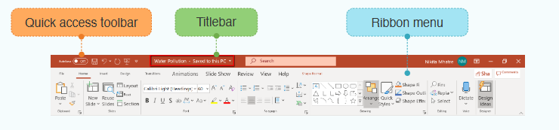
......................................
.......................
......................................
Good Luck

